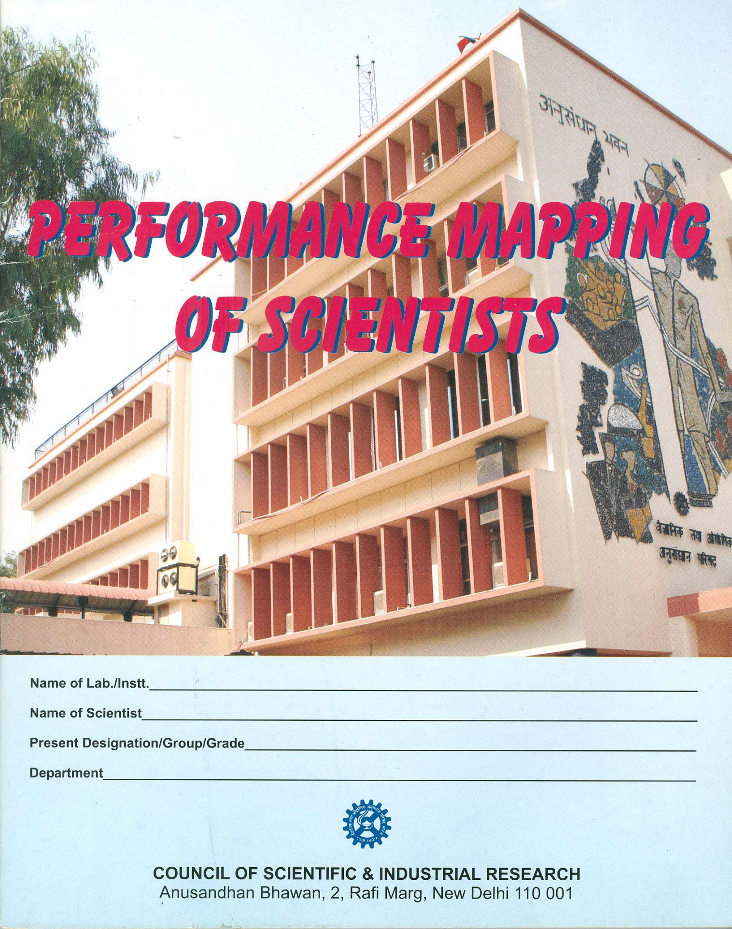

Folder No. ………………

Performance Mapping of Scientists
(FOR GROUP IV SCIENTISTS)

(FOR THE PERIOD FROM ………………………………TO…………………….

Name of the Lab./Instt.: ……………………………………………...

Name of the Scientist: …………………………………………….

Present Designation (Group / Grade): …………………………………………….

Present Division/ Department: …………………………………………...

Council of Scientific & Industrial Research

Appendix-A
Name of Lab/Instt _____________________________________________________________
Council of Scientific & Industrial Research
Performance Mapping for Scientists
Assessment Year ______________________________ to ______________________________
BASIC INFORMATION
Identification Information
Name of the Employee ……………………………………Employee ID…………………………
………………………………… ……………………………
Group/Grade ………………………………………… Date of Birth ………………………
Division/Department ………………………………………………………………………….....
Date of Joining CSIR …………………………………………………………………………….
Category (Indicate if belonging to SC/ST/OBC …………………………………………………..
Email ID …………………………………………………………………………………………
Mobile No. ………………………………………………………………………………………..
About the Evaluation Period (and other obligatory information)
Status ……………………………………………………………………………………………
Part year or full year evaluation ……………………………………………………………….....
Members-Collegiums …………………………………………………………….…………..…..
Members Empowered Committee ………………………………………..………………………..
Have you filled the annual return on immovable property during this evaluation period ………..
Categories information (for the period under evaluation)
CSIR Core Subject Area …………………………………………………………………………..
Further sub subject specialization of the area under which the activities have been carried out during the assessment period (refer: This may be different from the functional divisions of the Lab)

EDUCATIONAL ATTAINMENT(S)
Qualification | Specialization /Subject(s) | Year | Division (O-Not Applicable) | University/ Institute | Additional Information
EMPLOYMENT DETAILS
Grade / Post | Estt./Lab/Instt. | Duration From | Duration To | Remarks
LEAVE RECORD
Please list leave record for the year being evaluated (include all leave)
Type of leave | No. of days

Verified by COA/AO Signature of the Employee
Date: ……………… Date: ……………………
Questionnaire – Part I
Common to all (those in PB3 & PB4 scales)
Please provide detailed/additional relevant information at appropriate places as Annexures suitably marked/identified in the Work Report format as per Appendix-B wherever necessary. It is not expected that all sections of Appendix-B will be relevant to the concerned scientist and will be filled-in. ONLY those sections/sub-sections that are closely relevant to the concerned scientist need to be responded to or filled-in.

- What do you consider to be your most important achievements sector-wise for the past year? List sector-wise contribution in one or more areas (Public goods/Private goods/Strategic goods/Societal goods).

- Define your major knowledge portfolio – state whether you are involved in Knowledge Generation, Knowledge Development or Knowledge Management. Please elaborate by filling in the appropriate sections of the form provided in Appendix B.

Signature of the Employee
Place:
Date:
Questionnaire – Part II
(for only those in PB4 scale)
- How has your contribution enhanced the prestige of the Laboratory?

- In light of your current capabilities, your performance against past objectives, and your future personal growth and/or job aspirations, what activities and tasks would you like to focus on during the next 2-3 years. Again, also think of development and experiences outside of job skills-related to personal aims, fulfillment, passions, etc.

- What sort of training/experience would benefit you in the next year? Not just job-skills also your natural strengths and personal passions you’d like to develop – you, your work and team can benefit from these.

Place:
Date: Signature of the Employee
Appendix B
WORK REPORT FORMAT
(It is not expected that all sections/ sub- sections of Appendix-B will be relevant to the concerned scientist and will be filled-in. ONLY those sections/sub- sections that are closely relevant to the concerned scientist need to be responded to or filled-in.)
Section-I
Kindly ensure that there is no repetition while providing information.

I.1 Participation in the “R&D/R&D Managerial activities” of the Laboratory/Institute:
Sl.No. | Title of the Project | Project Category | Participating Agencies | Your Role as defined

I.2 Participation in “major programmes” and/or “facility creation” identified at the National level:
Sl.No. | Title of the Project | Coordinating Agency | Contribution being made by you as representative of your organization*

I.3 Acquisition, operation and maintenance of “major facilities” of the Laboratory/Institute:
Sl.No. | Title of the Facility | Your role in brief* | Beneficiaries*

I.4 Enlist notable contributions (upto ten, indicating status like individual achievement, output of a team work/collaborative work etc):

I.5 Highlights the significance/Impact of your work on industry/society/environment/nation as a whole
*(not more than 100 words)

Section II
II.1 Publications
II.1.1 Paper published in journals (during the year)
- In peer reviewed/SCI Journal (Indicate the total Impact factor and citations of your publications)
- In non peer reviewed Journal
- Review papers(non SCI Journal
Sl. No. | Authors | Title of the Article | Year of Pubn | Name of Journal | Country | Vol No. Issue pages | DOI
Note: Scientist is fully responsible for the accuracy of their references. All references must include
- Author/editor last name plus initials (for six or fewer authors; if there are more than six authors, use “et al.” after the sixth) or authoring agency
- Year of publication
- Full title of article or chapter (lower case)
- Title of journal (abbreviated according to standard engineering journal) or book/ proceedings in title case
- City/state/country of publication and name of publisher
- Volume and inclusive page numbers
- DOI number, if applicable.
II.1.2 Papers published in conference Proceedings
Sl. No. | Authors | Title of the Article | Date /Year | Name of Conference | Venue | Vol No. Pages | Publisher

II.1.3 Contribution to Books
(Indicate total number of chapters and pages)

SI No. | Editors | Title of the chapter | Year of publication | Title of book | Country | Edition No. | Publisher

II.1.4 Enlist institutional publications brought out
(specify the nature like Technical brochures, Organizational plans, Annual reports, Performance reports, Protocols, Brochures, IPR documents etc. )

II.2 Patents filed and granted during the assessment period (indicate separately total number of national and international patents filed and granted, also provide details as per format given below):
SI No. | Title | Country | Filed on (Date) | Granted on (Date) | Name of other inventors

II.3 Financial Contribution
II.3.1 ECF during assessment period:
Sl. No. | Title of the project | Project Type / Category | Amount received with your initiative | Govt. / Industry | Lab Reserve generation

II.3.2 Technology/ Process/ know-how transferred:
SI. No | Title | Period during which developed | Date of transfer | Organization/ industry | Total fees realised | Your Role*

II.3.3 Testing, Evaluation and Caliberation jobs undertaken and amount charged
II.3.4 No. of EIA jobs undertaken and amount charged
II.3.5 Software developed and delivered and amount charged
II.3.6 Others (specify, if any)
II.4 Technology/ Process/ Product Development:
SI No. | Title | Year of Development | Your contribution in development*

*not more than ten words
In case your work such as ‘spin-offs’ etc., cannot be depicted in terms of the above parameters, you may like to quantify your contributions in your own way and while doing so you may prefer to section/para No.(s), in case such points are already reflected elsewhere in this report.

Section III
Kindly provide details on the following, whatever applicable total information being within 300 words

III.1 Field work undertaken
- Field data collection (including oceanic data) indicating the number of days involved per year
- Field implementation/ technology diffusion
- Technological guidance/ counseling

III.2 ECF catalyzed and budget handled (CSIR & other agencies)
III.3 Participation and contributions made for strategic sector
III.4 Have you been able to create/ add new clients to the organization
III.5 Contribution to indigenous technology/ component/product/device/engineering system design
& development
III.6 Activities leading to foreign exchange saving
III.7 S&T cooperation established with other countries including regional collaboration
III.8 Assistance provided for national/international institution building
III.9 National/International training programs organized
III.10 Your contribution towards upliftment of Science & technology in country
III.11 Any other point, not covered so far, to complete the spectrum of your achievements

Section IV
Kindly provide information on following lines, whatever applicable, within 300 words
IV.1. Participation in policy formulation and/or decision making

IV.2. Formulating/amending existing rules/procedures for better effective functioning or the organization

IV.3. Interacting within CSIR, with other R&D Organizations, Govt. Departments, Industry and/or
International Agencies for projectt formulation or meeting effectively the objectives of
identified programmes.

IV.4. Obtaining/processing for the financial approval and associated management for implementing
mega projects.

IV.5. Providing major service to your organization in its efficient functioning & image building.

IV.6. Membership in organizational/national/international committees.

IV.7. Important administrative responsibilities taken and success achieved.

IV.8. Major events organized as leader/coordinator.

IV.9. Major initiative taken towards better positioning of your organization.

IV.10. Any other dimension of your contribution essentially depicting your leadership quality.
Section V
Participation/Contribution to AcSIR/HRD

V.1. No. of lectures delivered and details
SI No. | Subject/Course | Credits | No. of students | No. of lecture Hours | No. of practical sessions

V.2. Did you have a role in the design of curriculum of any subject?
(under 100 words)

V.3. What other contributions you have made to the academy this year?
(under 150 words)

V.4. Did you prepare any lecture notes, tutorials, test/assignments etc.
(under 100 words)

V.5. Please explain any other responsibility you have been assigned/undertaken including teaching PG/PhD students in 150 words.

V.6. No. of MS(Research) ,PhD. Students guided (indicate whether in progress or completed/awarded)

V.7. Students guided for their project work/assignments for PG Course like M.Sc./M.E./M/Tech./MBA/MCA etc.?

Section VI

Provide salient details including the name of the organization and the year of award, on the following.
VI.1. Fellowships of the professional societies (restricted to all India level selections only, besides international selections, if any)

VI.2. Prestigious award/recognition received (restricted to national & international level recognitions only, kindly also indicate in monetary terms, wherever applicable)

VI.3. Editorship in reputed journals

Date (Signature of scientist)

NB: Correctness of the information provided as above, is crucial as the assessment is based fully on
the Work Report forwarded to the Collegium for the purpose.

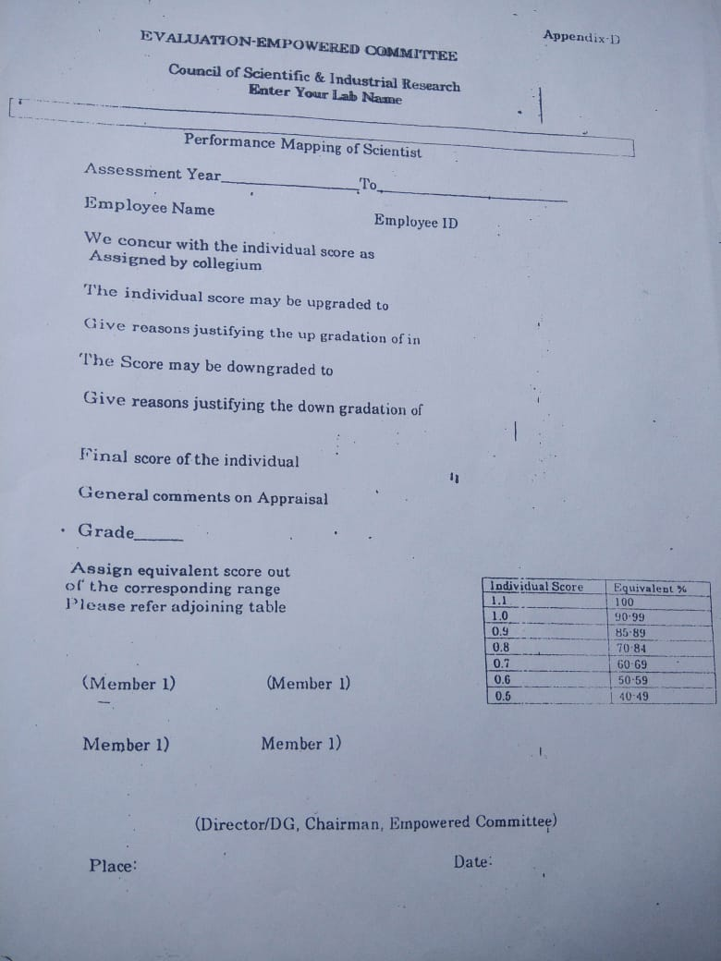

Appendix-C
EVALUATION-COLLEGIUM
Name of Lab/Instt _____________________________________________________________
Council of Scientific & Industrial Research
Performance Mapping for Scientists
Assessment Year ______________________________ to ______________________________
Name of the Employee ______________________________ Employee ID________________
Pen Picture (Behavioral Aspects)
A. | PERSONAL ATTRIBUTES | Excellent | Very Good | Good | Needs to be Improved
 | 1. Personality
 | 2. Maturity and logical thinking
 | 3. Level of self confidence
 | 4. Initiative and drive
 | 5. Mental alertness
B. | PROFESSIONAL COMPETENCE
 | - Perception of organizational role
 | - Competence to handle the job
 | - Ability to communicate(both in speech and writing)
 | - Dedication and commitment to the job
- Comprehension and appreciation
of new development related job
C. | MANAGERIAL CAPABILITIES
 | - Ability to get along with colleagues
 | - Willingness to accept responsibility
 | - Decision making ability
 | - Crisis handling
 | - Qualities to leadership
D. | INTEGRITY AND ETHICS  (Please refer Appendix E before filing this column) |  | Impeccable |  | Beyond Doubt
 |  |  | To be Monitored
E. | Any Adverse Comment  (if Yes, give details separately) | Yes/No
 | Total Individual Score |  | Below 0.70 (Specify)

(Member 1) (Member 2) (Member 3) Members Collegium

Place: Date:
Appendix-D
EVALUATION-EMPOWERED COMMITTEE
Name of Lab/Instt _____________________________________________________________
Council of Scientific & Industrial Research
Performance Mapping for Scientists
Assessment Year ______________________________ to ______________________________
Name of the Employee ______________________________ Employee ID________________
We concur with the individual score as
Assigned by the collegiums ………………………………………………….

The individual score may be upgraded to …………………………………………………
Give reasons justifying the up gradation of the individual score
The score may be downgraded to ………………………………………………..
Give reasons justifying the down gradation of the individual score

Final score of the individual ………….………………………………………
General comments on Appraisal
Grade: . ………….……..……………………………….

(Member 1) (Member 2)

(Member 3) (Member 4)

(Director/DG/Chairman, Empowered Committee)
Place: Date:

1.0 Introduction

Once an annual ritual, performance appraisal has become a continuous process by which an employee understands Council's and the Laboratory's goals and his or her progress towards contributing to them are measured. Performance measurement is an ongoing activity for all R&D Scientists and R&D Management Scientists.

Performance measurement uses the following indicators/parameters of performance, as well as assessments of those indicators.

i) Quantity: The number of units earned is a good objective indicator of performance.
One needs to be careful of placing too much emphasis on quantity, lest quality suffer.

ii) Quality: The quality of work performed can be measured by several means. The percentage of work output that must be redone or is rejected is one such indicator. In a research or support environment, the percentage of studies/services converted to effective output and outcomes is an indicator of scientist's quality, capacity, competence and ability.

iii) Timeliness: How fast work is performed is another performance indicator that should be used with caution. In field of research, this has to be weighed against the Laboratory's average and overall performance.

iv) Cost-Effectiveness: The cost of work performed should be used as a measure of performance only if the employee has some degree of control over costs.

v) Absenteeism/Tardiness: An employee is obviously not performing when he or she is not at work. Other employees' performance may be adversely impacted by absences, too as most of the measure of success of projects in CSIR are a team effort.

vi) Creativity: It can be difficult to quantify creativity as a performance indicator, but in R&D tasks, it is vitally important. Scientists and team leaders/project leaders/Division Heads should keep track of creative work examples and attempt to quantify them.

vii) Adherence to Policy/Vision/Mission: This may seem to be the opposite of creativity, but it is merely a boundary on creativity. Deviations from policy/vision/missions indicate an employee whose performance goals are not well aligned with those of the laboratory.

Performance Mapping of Scientists

viii) Personal Habits: They may not seem performance-related to the employee, but some personal habits, like gossip, can detract from task/work performance and interfere with the performance of other team members. The specific behaviors should be defined, and goals should be set for reducing their frequency.

ix) Work ethics: Most people know how to conduct themselves for work with work ethics, however there is a possibility that someone needs to be told. Examples of inappropriate appearance and conduct should be spelled out, their effects upon the employee's performance and that of others explained, and corrective actions
defined.

2.0 APAR/ARP Procedure Revision Committee

One of the main reasons for revision in procedure was due to the DoPT circulars regarding maintenance of Annual Appraisal Reports, Transparency and Fairness etc. An APAR Procedure Revision Committee under the chairmanship of Dr. Nagesh R Iyer was constituted to ensure adoption of participative determination of performance dimensions and objective method of assessment and communicating of Annual Performance Appraisal reports including overall grades to the employees. The Committee revisited the existing system and a system has been proposed to ensure objective methods of assessment. Further, the system proposed is flexible and is proposed to be integrated with the Enterprise Application Solution undertaken by CSIR
under the CSIR Transformation initiative.

3.0 Present System

The Assessment process in the present system goes through the following three stages of evaluation

i) Self Appraisal

ii) Appraisal by Reporting Officer
iii) Appraisal by Reviewing Officer

i) Self-Appraisal:

The scientist appraises his or her own performance, in many cases comparing the self- appraisal to reporting officer's review. Often, self-appraisals can highlight discrepancies between what the employee and management think are important performance factors and provide mutual feedback for meaningful adjustment of expectations.

The employee gives both qualitative and quantitative description of the Tasks assigned to him during the assessment year and the actual outcomes against each

task. This report is then reviewed by the reporting officer who evaluates the employee based on the tangible and intangible deliverables of the employee.

Performance indicators must be assessed by some means in order to measure performance itself. Here are some of the ways in which performance is assessed from the aforementioned indicators.

ii) Appraisal by Reporting Officer:

A reporting officer appraises the employee's performance and delivers the appraisal to the employee through the Reviewing Officer/Head of the Institution. Appraisal by Reporting Officer is through critical examination and study of the work report submitted along with the self-appraisal form.

iii) Appraisal by Reviewing Officer/Normalization Committee:

The reviewing Officer and or the Normalization Committee objectively looks at the self- appraisal of the candidate, report provided by the corresponding Reporting Officer and the overall laboratory performance/average. Based on these inputs, a critical appraisal is made to agree or, to upgrade or downgrade the marks awarded with recording of justification for such an action. The entire appraisal with its contents is communicated to the employee. Members of the Normalization Committee should be at least of the rank of Scientist Gr. IV (6).

4.0 Proposed System

After reviewing the personnel policies of CSIR for the last four decades, it is strongly felt that the self appraisal methodology is the best form of evaluation that is completely transparent and can be made highly objective. The concept of reporting officer and reviewing officer has been done away with. This would make the process of assessment easier, simpler and straightforward.

A novel method has been designed to capture the work outputs and outcomes of the scientist through a questionnaire given below. The scientists are expected to provide detailed/additional relevant information at appropriate places as Annexures suitably marked/identified which In their opinion truly reflects the measure of performance.

The proposed system also has three stages of evaluation which are as follows:

>- Stage I - Self Appraisal by Scientist (by filing a questionnaire)
>- Stage II - Evaluation by Collegium which is done by assigning marks based on the inputs provided by the Scientist through the Self Appraisal Questionnaire.
>- Stage III - Evaluation by Empowered Committee based on the inputs provide by the Collegium

Individual forms have been designed in MSWord to be filled by the Scientist, the Collegium and the empowered committee.

Performance Mapping of Scientists

4. 1 Stage I: Self Appraisal

The purpose of the self-appraisal is to seek relevant information in a manner that would clearly bring out the contributions/achievements, etc. of the scientist for objective evaluation by the Collegium.

Goals of the Appraisal Process

• facilitate communication of all aspects of performance between the scientist and the
Collegium/Empowered Committee

- identify areas in which improvement and learning will help the scientist become more
successful in the future, allowing him/her to make further contributions to CSIR

• identify individual development needs, desires and plans

• establish a permanent record of the employee's work history, which is as straight- forward and objective as possible

• serve as one of the basis for assessment for promotion and

• incorporate goals for meeting career development plan of the scientist

Considering the above, a questionnaire has been designed for the Scientists. This has two parts. Part I has 2 questions common to Scientists in Pay Bands 3 and 4 (PB3 and PB4). Part II has 3 questions that need to be answered by only those in PB4. The scientists have to fill the Questionnaire as detailed in Appendix-A. The scientist has to provide detailed information through annexures wherever required along with other basic details based on the Work Report format provided in Appendix-B. It is not expected that all sections of Appendix-B will be relevant to the concerned scientist and will be filled-in. ONLY those sections/sub-sections that are closely relevant to the concerned scientist need to be responded to or filled-in. This entire set has to be forwarded to the Chairman of the Collegium.

Performance Mapping of Scientists

Questionnaire - Part I

Common to all (those in PB3 & PB4 scales)

SI.  No. | Question  (Provide additional supporting information as annexures in the Work Report format as per Appendix-B wherever necessary. It is not expected that all sections of Appendix-B will be relevant to the concerned scientist and will be filled-in. ONLYthose sections/sub-sections that are closely relevant to the concerned scientist need to be responded to or filled-in.)
1) | What do you consider to be your most important achievements sector-wise for the past year? List sector-wise contribution in one or more areas. (Public goods/Private goods/Strategic goods/Societal goods*).
2) | Define your major knowledge portfolio - state whether you are involved in Knowledge Generation, Knowledge Development or Knowledge Management. Please elaborate by filling in the appropriate sections of the form provided in Appendix B.

Questionnaire - Part II
(for those who are on PB4 scale)

3) How has your contribution enhanced the prestige of the laboratory?

4) In light of your current capabilities, your performance against past objectives, and your future personal growth and/or job aspirations, what activities and tasks would you like to focus on during the next year? Again, also think of development and experiences outside of job skills - related to personal aims, fulfillment, passions, etc.

5) What sort of training/experiences would benefit you in the next year? Not just job-skills - also your natural strengths and personal passions you'd like to develop - you, your work and team can benefit from these

Performance Mapping of Scientists

i) Public
*Broad definitions of Public, Private, Social and Strategic Goods

Basic research as reflected by publications, development of standards, databases, etc., and the policy support to government could be classified under public goods as they meet the criteria of non-rivalry and non-excludability.

ii) Private

Industrial training programmes, consultancy services, certification and testing services, and sponsored research are considered as private goods as beneficiary preferences is reflected in their willingness to pay for these services. Intellectual property, particularly patents, technologies, products, processes and copyrights are in the private domain, but public funds have been used both at their generation (project) stage and at the patenting stage.

iii) Social/Societal

Social/Societal good element is evident in activities, which generate livelihood opportunities to people located in far-off regions or to poor as in development of technologies, which use traditional knowledge, and use of local resources endowments. Examples include natural hazard/disaster mitigation, environmental benefits from development use of technologies such as for coal-washing, mine safety, eco-friendly products and processes, pollution prevention and abatement.

iv) Strategic

Strategic goods are those that are visible in the activities directly related to achieving self-reliance and services that meet the national/indigenous needs including national security for which no solution is available and enables creating technological options and 'resource centres', 'spin-offs', etc.

4.2 Stage II: Collegium

After submission of the self-appraisal by the scientist. the Committee recommends two-level evaluation process to be followed. The first level of evaluation is by a Collegium to be duly constituted by the Director/DG in case of CSIR-HOfor different grades/levels of scientists and the second level of evaluation is through an Empowered Committee that also includes the Head (Director) of the Laboratory.

The following is the proposed composition of the Collegiums for evaluation of Scientists in their respective Grades to be constituted by the Director of the Laboratory or DG in the case of CSIR-HQ.

Performance Mapping of Scientists

Collegium | Scientist Grade | Composition of Collegium
I | Scientist Band  Scientist C | Group/Grade  Scientist E-I/II | Nos.  1
 |  | Scientist F/G | 1
 |  | Scientist from the Empowered  Committee | 1
II | Scientist E I | Scientist EII/F | 1
 |  | Scientist G | 1
 |  | Scientist from the Empowered  Committee | 1
III | Scientist E II | Scientist F/G/H | 2
 |  | Scientist from the Empowered  Committee | 1
IV | Scientist F | Scientist G/H/I | 2
 |  | Scientist from the Empowered  Committee | 1

The Collegium should segregate the self-appraisal forms received as per the major knowledge portfolio defined by the scientist. The evaluation of the scientist will be based on the knowledg,e portfolio defined therein.

The composition of the Collegium is only indicative and the actual number of members under each Collegium and the number of Collegiums can be decided based on the size and composition of scientists in the Laboratory/Division. For a large size lab, Director may like to have collegiums for every division. However, a lab can have up to a maximum of SIX divisions. A scientist nominated from the Empowered Committee will act as the Chairman. However, it may be seen that total number of members in the Collegium including the Chairman should be odd.

4.2.1 Computation of Resultant Score of Scientist: The Collegium evaluates the responses provided by the concerned scientist to the Questionnaire (Part I or Parts I & II as the case may be) and assigns a score after careful study. Depending on the performance of the individual, the score of the candidate assigned by the collegium will be in the band of 0.7 to 1.0 (both included and exceptions in cases as applicable/explained later).

A+ ≡1.0, A ≡ 0.9, A-≡ 0.8 and B ≡ 0.7

It is recommended that the score assigned should relate to the overall performance of the laboratory. A laboratory may choose through Empowered Committee a robust and reasonable method to determine performance average lab score that is normalized to a score of 1.0. The grading A+ to B proposed can correspond to this.

Performance Mapping of Scientists

Normal Residency Period is assumed to be R

Sr. | Possible Resultant | Equivalent % | Grade | Effective Residency Period
No. | Individual Scores |  |  | (Re)for next assessment
1. | 1.1 | Exceptional | Exceptional | For immediate consideration
2. | 1.0 | 91-100 | Excellent | Re= (R-1)
3. | 0.9 | 85-90 | Very Good | Re= R
4. | 0.8 | 80-84 | Good | Re = (R+1)
5. | 0.7' | 75-79 | Fair | Re = (R+2)
6. | below 0.7 | below 75 | Satisfactory | Re = (R+3)

Individuals within the laboratory with exceptional performance or "outlier" can be given an individual score of 1.1. For exceptional and rewarding cases, one may refer to Annexure-II for illustrations. At the same time if the performance of the candidate is far below par and far away from the lab average, he may be graded below 0.7 stating clearly the reason that would be communicated to the candidate.
A general explanation of the grades but not necessarily exact is given below:

Exceptional: Individuals within the laboratory with exceptional performance or "outlier" can be given an individual score of 1.1. Exceptional means the performance is exemplary and falls into the top 1% of the scientists. Besides his performance in all round sectors/goods (public, private, societal, strategic, etc.), should have also received recognition in the form of prestigious awards such as Shanti Swarup Bhatnagar, fellowship of Academy, etc. For additional information please refer to Annexure-I. As recognition of the splendid performance, the scientist can be considered for immediate assessment to the next higher scientific grade.

Excellent: Excellent means significantly exceeds CSIR's expectations. This is reserved for those whose performance during the review period falls into the top· 20% of the scientists at their level. As a motivating factor and a strong support to pursue the outstanding work, the candidate receiving the "Excellent" grade will be assessed ONE YEAR ahead of the normal residency period* in his present scientist grade.

Very Good: Very Good means that candidate just meets CSIR's expectations; however there is scope for making significant contributions that would exceed the expectations.

Performance Mapping of Scientists

Therefore, the candidate assigned the "Very Good" grade will be assessed as per the normal residency period* with a view to provide an opportunity to be consistent with achieving CSIR's superior standards and improve the performance in the following years.

Good: means the candidate just falls short of CSIR's expectations and in achieving CSIR's superior standards. The candidate who has been awarded "Good" grade will be assessed
ONE YEAR later than the normal residency period * in his present scientist grade.

Fair: Needs to demonstrate additional effort and or undertake further skill development. Identifies an area that would benefit from additional attention and resources and requires specific recommendations for areas of development. The candidate who has been awarded "Fair" grade will be assessed TWO YEARS later than the normal residency period* in his present scientist grade.

Satisfactory: Does not meet expectations. Requires an immediate improvement plan with specific deadlines to meet goals to bring performance up to a minimum level. The candidate who has been awarded "Satisfactory" grade will be assessed THREE YEARS later than the normal residency period* in his present scientist grade.

* The normal residency period and all related qualifying criteria including earlier/delayed assessment for a scientist in his corresponding grade is governed by the policy adopted by RAB. Therefore, no effort is made to detail the concerned criteria and other related matter as it is outside the scope of this committee.

The form designed in MSWord for the scientist to be filled-in is given in Appendix-A, whereas the form for evaluation by the Collegiums is presented in Appendix-C. The Collegium also evaluates the following Behavioral aspects and assesses the employee accordingly.

A. PERSONALATTRIBUTES
1. Personality

2. Maturity and logical thinking

3. level of self-confidence

4. Initiative and drive

5. Mental alertness

B. PROFESSIONALCOMPETENCE
1. Perception of organizational role
2. Competence to handle the job
3. Ability to Communicate (both in speech and writing)

4. Dedication and commitment to the job
5. Comprehension and appreciation of new development related to his job

Performance Mapping of Scientists

C. MANAGERIAL CAPABILITIES
1. Ability to get along with colleagues

2. Willingness to accept responsibility

3. Decision making ability

4. Crisis handling

5. Qualities of Leadership

This is also presented as a part of Appendix-C for evaluation by the Collegium. The Collegium will state its comments on the overall qualities of the scientist including areas of strengths and if necessary areas needing improvement. Along with the evaluation of the scientist, the Collegium will also submit its opinion on the integrity of the scientist. The integrity and ethics part is mandatory as per the GOI OM No. 51/5/72-Estt "A" 20 May 1972 which is reproduced in Appendix-E. The evaluation report of the Collegium is then submitted to the Empowered Committee which does the final evaluation.

4.3 Stage III: Empowered Committee

The assessment of the Collegium would be reviewed by a duly constituted Empowered committee.

4.3.1 Constitution of the Empowered Committee

The Empowered Committee will be constituted by the Director of the laboratory or DG in the case of CSIR HQ. The Empowered Committee will consist of 2/4/6 Scientist G/H/I (depending on the strength of the laboratory) and the Director of the Laboratory or DG in case of HQ. However, it may be seen that total number of members including Chairman in the Committee should be odd.

The inputs of the Collegium are then carried forward to the Empowered Committee which can give its final evaluation and assign a suitable grade. This grade is communicated to the scientist. The Empowered Committee can revise the marks awarded by the Collegium citing clear and unambiguous justification. It is recommended that any upgrade or downgrade of marks at this stage can be considered based on the following:

- Basic character/nature of the Laboratory
- Average performance of the Laboratory

The forms designed in MSWord for the empowered committee are given at Appendix-D. Forms generated as a result of the evaluation by the concerned Collegium and the Empowered Committee as per Appendices C and D are communicated to the employee. A typical flow of the appraisal process is shown in Fig. 1.

It is proposed to build the entire flow in the enterprise application being developed as part of the CSIR enterprise solution.

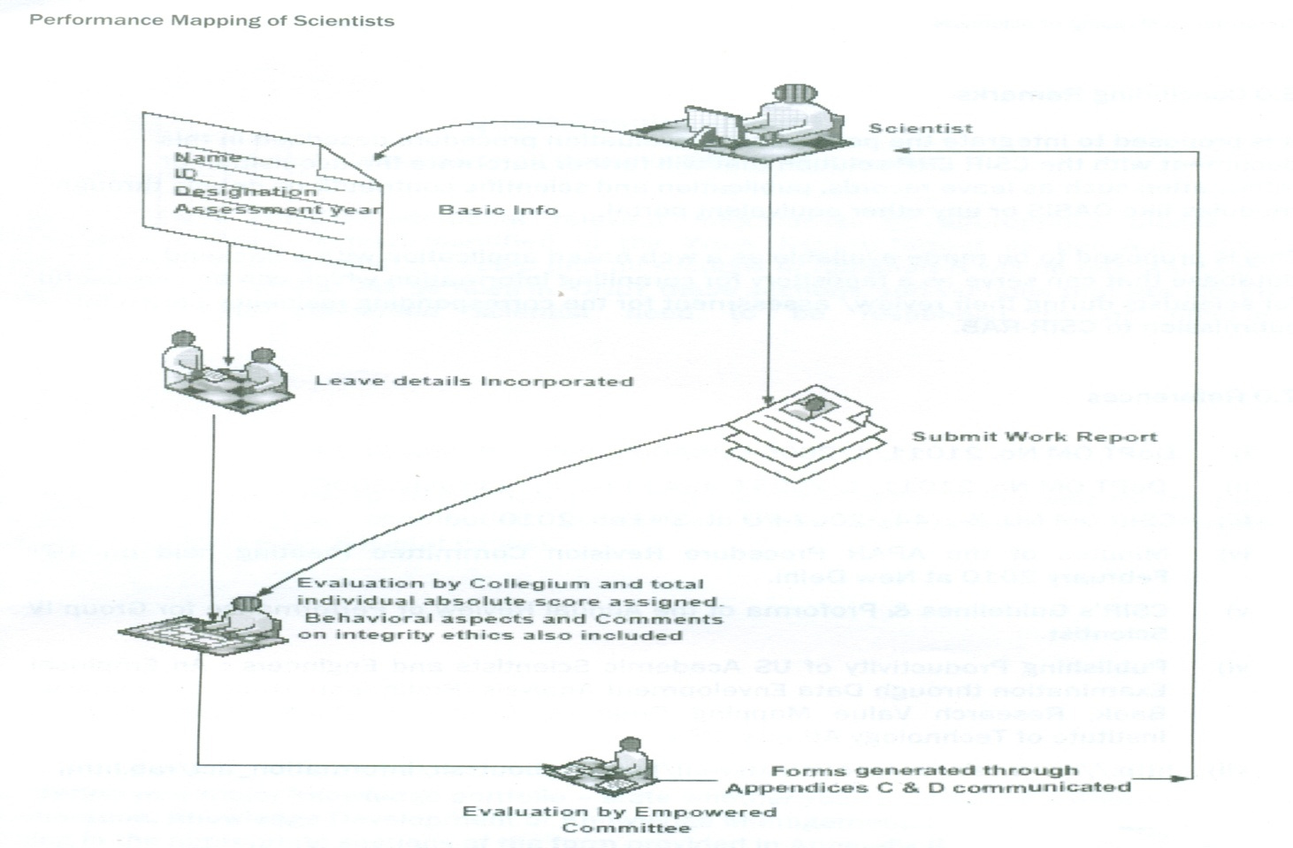

Fig. 1 Employee Appraisal Process

5.0 Acknowledgements

The authors are grateful to Prof. Samir K Brahmachari, Director-General, CSIR and Secretary, DSIR for constant support, guidance, advice and direction towards quantitatively assessing the scientist through performance value mapping. The authors would also like to thank Dr. S. Sivaram, Director, CSIR-NCL, Pune for his support and guidance in the process of revising the APAR procedures. Thanks are also due to Ms. S. Vijayalakshmi, Nodal Officer, Knowledge Network Unit, CSIR-SERCfor developing the system and the processes using the IT tools. The authors gratefully acknowledge the inputs towards consideration of "exceptional" and rewarding cases of scientists by Dr. T. Chandrashekar, Director, CSIR- CEERI.

Performance Mapping of Scientists

6.0 Concluding Remarks

It is proposed to integrate the performance evaluation procedure described in this document with the CSIRERPsolution that will further automate the acquisition of information such as leave records, publication and scientific contributions details through modules like OASISor any other equivalent portal.

This is proposed to be made available as a web based application with a backend database that can serve as a repository for compiling information which can be very useful for scientists during their review/ assessment for the corresponding residency period for submission to CSIR-RAB.

7.0 References

i) DoPTOM No. 21011/1/2005-Estt(AO(Pt-lI) dt. 14th May 2009
ii) DoPTOM No. 21011/1/2005-Estt(AO(Pt-lI) dt. 23rd July 2009
iii) CSIROM NO. 5-1(44)/2007-PD dt. 3rd Feb. 2010
iv) Minutes of the APAR Procedure Revision Committee meeting held on19th February 2010 at
New Delhi.

v) CSIR's Guidelines & Proforma of the Annual Review of Performance for Group IV Scientist

vi) Publishing Productivity of US Academic Scientists and Engineers: An Empirical Examination through Data Envelopment Analysis (Preliminary Draft) by Youngsun Baek, Research Value Mapping Program, School of Public Policy, Georgia Institute of Technology Atlanta, USA

vii) http://www.csir.res.in/csir/externaljheads/aboutcsir/information_actjrab.html

Performance Mapping of Scientists

Appendix-E

Integrity and Ethics: Please read the following guidelines before evaluating the employee for Integrity and ethics.

Guidelines issued by the Government of India, Department of Personnel, regarding, 'Integrity', vide O.M.No. 51/5/72-ESTT 'A' dated 20 May 1972.

In every form of confidential Report there should be a column regarding integrity to enable the Reporting Officer to make his remarks on the integrity of the Government servant reported upon. The following guidelines should be followed in the manner of making entries in the column relating to integrity:
a) Supervisory Officer should maintain a confidential diary in which instances which create suspicion about the integrity of a subordinate should be noted from time to time and action to verify the truth of such suspicion should be taken expeditiously by making confidential enquiries departmentally or by referring the matter to the special police establishment. At the time of recording the Annual Confidential Report his diary should be consulted and the material in it utilized for filing, in the column relating to integrity. If the column is not filled on account of the unconfirmed nature of the suspicious, further action should be taken in accordance with the following sub-paragraphs.

b) The column pertaining to integrity in the character Roll should be left blank and a separate secret note about the doubts and suspicions regarding the Government servants integrity should be recorded simultaneously and followed up.

c) A copy of the secret note should be sent together with the character roll to the next superior officer who should ensure that the follow up action is taken expeditiously.

d) If, as a result of the follow-up action, a Government servant is exonerated, his integrity should be certified and an entry made in the character roll.

e) If suspicions regarding his integrity are confirmed, this fact can also be recorded and duly communicated to the Government servant concerned.

f) There may be cases in which after a secret report/note has been recorded expressing suspicion about a Government servant's integrity, the inquiries that follow or not disclose sufficient material to remove the suspicion or to 'confirm' it. In such a case the government servant's conduct should be watched for a further period, and in the meantime, he should as far as possible be kept away from positions in which there are opportunities for Indulging in corrupt practices and thereafter action taken as indicated at(d) and(e) above.

There are occasions when a reporting officer cannot in fairness to himself and to the government servant reported upon, either certify integrity or make an adverse entry or even be in possession of any information which would enable him to make a secret report to the head of the department. Such instances can occur when a government servant is serving in a remote station and the reporting officer has not had occasion to watch his work closely or when a government servant has worked under the reporting officer only for a brief period or has been on a long leave etc. In all such cases, the Reporting officer should make an entry in the integrity column to the effect that he has not watched the government servant's work for sufficient time to be able to make any definite remark or that he has heard nothing against the government servant's integrity, as the case may be. This would be a factual statement to which there can be no objection. But it is necessary that a superior officer should make every effort to form a definite judgment about the integrity of those working under him, as early as possible, so that he may be able to make a positive statement.

------_

Performance Mapping of Scientists

Performance Related Incentive Scheme (PRIS)
for CSIR Employees
Annexure-I

Pursuant to the provisions of Performance Related Incentive Scheme for government employees under the 6th pay commission, CSIR, through a process of consultation with some of the cluster directors has evolved a PRIS for CSIR employees who are in tune with the roles and goals of CSIR Rather than offer variable increment, CSIR has evolved a set of objective norms and transparent methods for rewarding performance at both individual and team levels by recognizing performance through a set of objective criteria.

Accordingly, the PRIS implementation for CSIR is proposed as follows:
(Please note that these are proposals and indicators. thus not complete!)

1. Incentive for Peaks in Science: (Incentivising generation of high quality public goods) For a research paper authored/coauthored by CSIR scientist(s) and published by "Nature" or "Science", the corresponding CSIR author would be considered for immediate assessment.

2. Incentive for generation of high quality private goods:

2a). Incentive for Technology Transfer:

If in a financial year one or more technologies developed by a team are transferred to industry for a combined license fee equal to or exceeding US $1million (or equivalent rupees), then all the team members belonging to groups IV, III and II will receive the benefit of one year early promotion at the time of their next assessment whenever it becomes due.

2b). If a company makes an investment of more than US $10million (or equivalent rupees) based on a CSIR technology, all the members of the technology development team belonging to Groups IV, III and II will receive the benefit of one year early promotion at the time of their next assessment whenever it becomes due.

3. Incentive for generation of high quality strategic goods:

If a technological contribution for the strategic sector is adjudged valuable by the RC of the Laboratory and is also acknowledged by the strategic sector user/partner, then all the members of the technology development team belonging to Groups IV, "I and" will receive the benefit of one year early promotion at the time of their next assessment whenever it becomes due.

4. Incentive for generation of high quality social goods:

If a technology developed for the social sector touches upon and improves the life/well- being/livelihood of an estimated ten thousand families, then all the members of the
Performance Mapping of Scientists

technology development team belonging to Groups IV, III and II will receive the benefit of one year early promotion at the time of their next assessment, whenever it becomes due.

5. Incentivisation for recognition at the national and international levels:

If a scientist receives a major national/international award, then he would be promoted to the position/grade pay w.e.f. the date of receipt of the award. The qualifying award will be decided/approved by DG,CSIR.

If group IV/III/II staff member becomes eligible for promotional benefits under more than one categories simultaneously, he will be given an additional one increment per additional category over and above the promotional benefit associated with the main category (to be chosen by the scientist) at the time of his assessment/promotion whenever it becomes due. The amount of increment for this purpose would be determined to be 3% of the pay plus grade pay of the minimum of the scale to which the person is being promoted.

